- Write a program that prints the addresses of code, global, static, heap, and stack variables. Analyze the Linux process address space layout and explain each memory segment.

Make use of the /proc//maps file and memory analysis tools to study the memory organization of a running process. Prepare a report explaining virtual memory mappings.

OUTPUT :

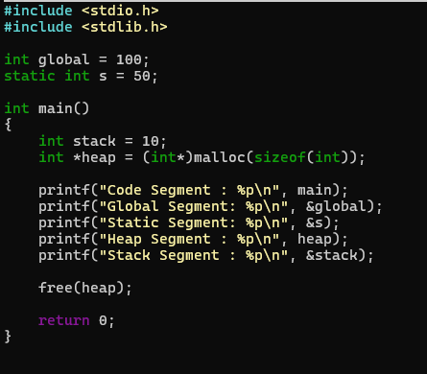

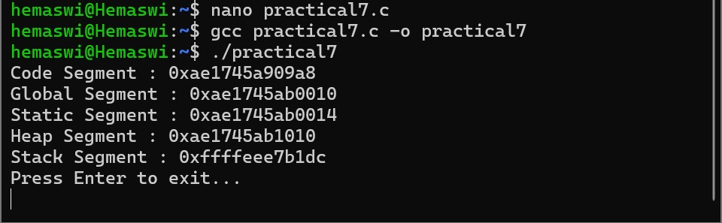

- Develop a program using malloc(), calloc(), realloc(), and free(). Monitor memory allocation behavior and identify memory leaks using Valgrind.

Develop a program that demonstrates Copy-on-Write behavior after a fork(). Analyze memory usage before and after modifying data in the child process.

OUTPUT :

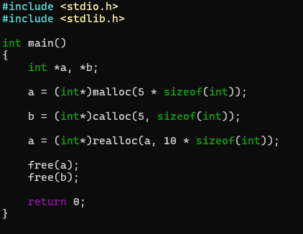

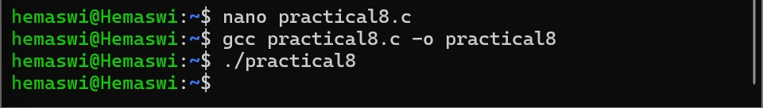

8(B) :

